Computer Science ATAR Year 12 - Task 6 Part 1
Trading Card Platform Management System (Pokemon TCG)

Pokemon brief explanation
Pokemon Trading Card Game is a competitive strategy card game where players use 60-card decks to battle by attacking opposing Pokemon and collecting Prize cards. The administration system in this project manages core platform data used by staff: players, cards, deck lists, tournaments, and tournament registrations.
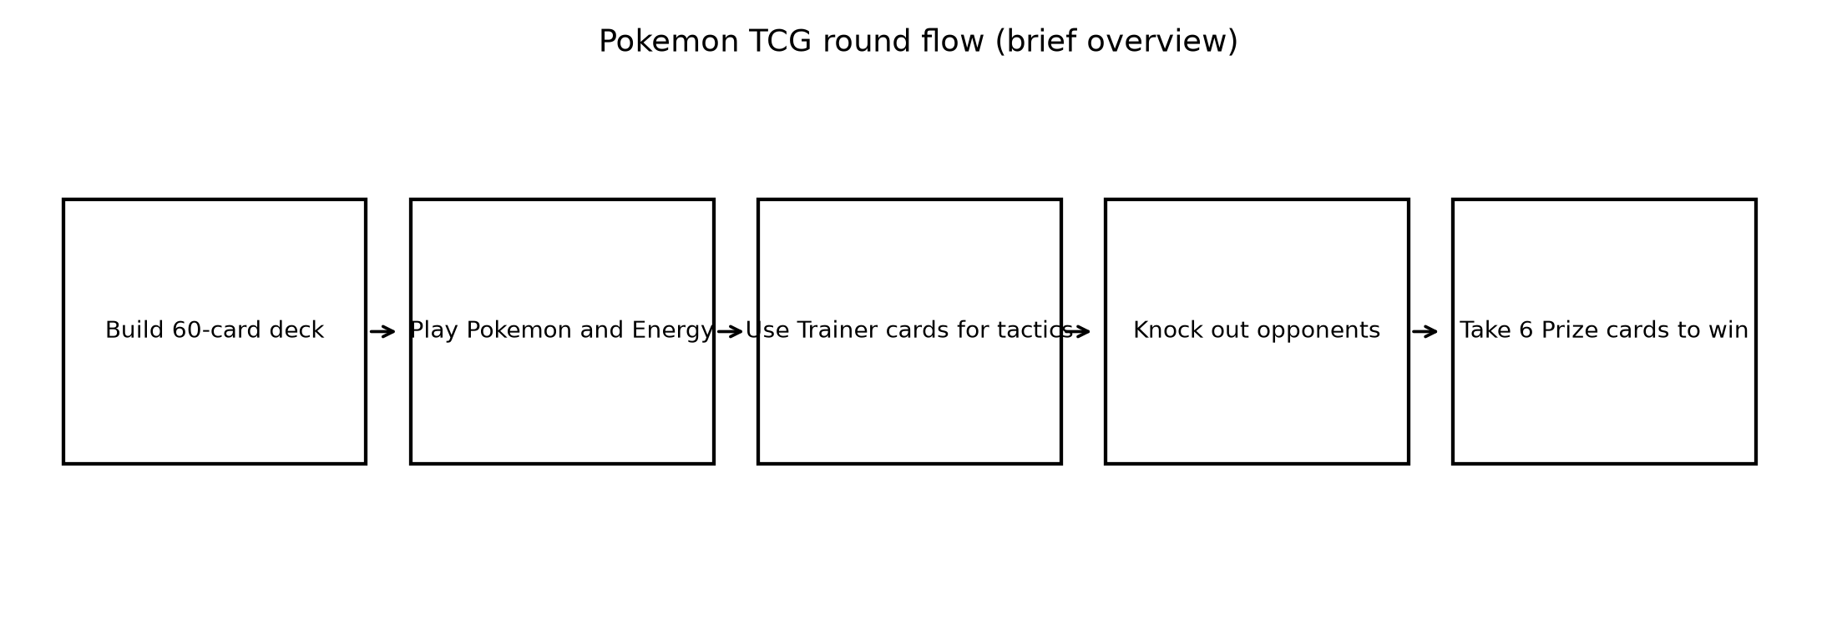

Pokemon card types and purposes
This project models all core card categories used in deck construction and tournament operations:
- Pokemon cards: active/bench battlers; include Basic, Stage 1, and Stage 2 progression.
- Energy cards: basic or special energy used to power attacks and abilities.
- Trainer Item cards: quick tactical effects with no one-per-turn limit.
- Trainer Supporter cards: stronger effects, restricted to one per turn.
- Trainer Stadium cards: persistent board-wide effects until replaced.
- Trainer Pokemon Tool cards: attached equipment that modifies a Pokemon.
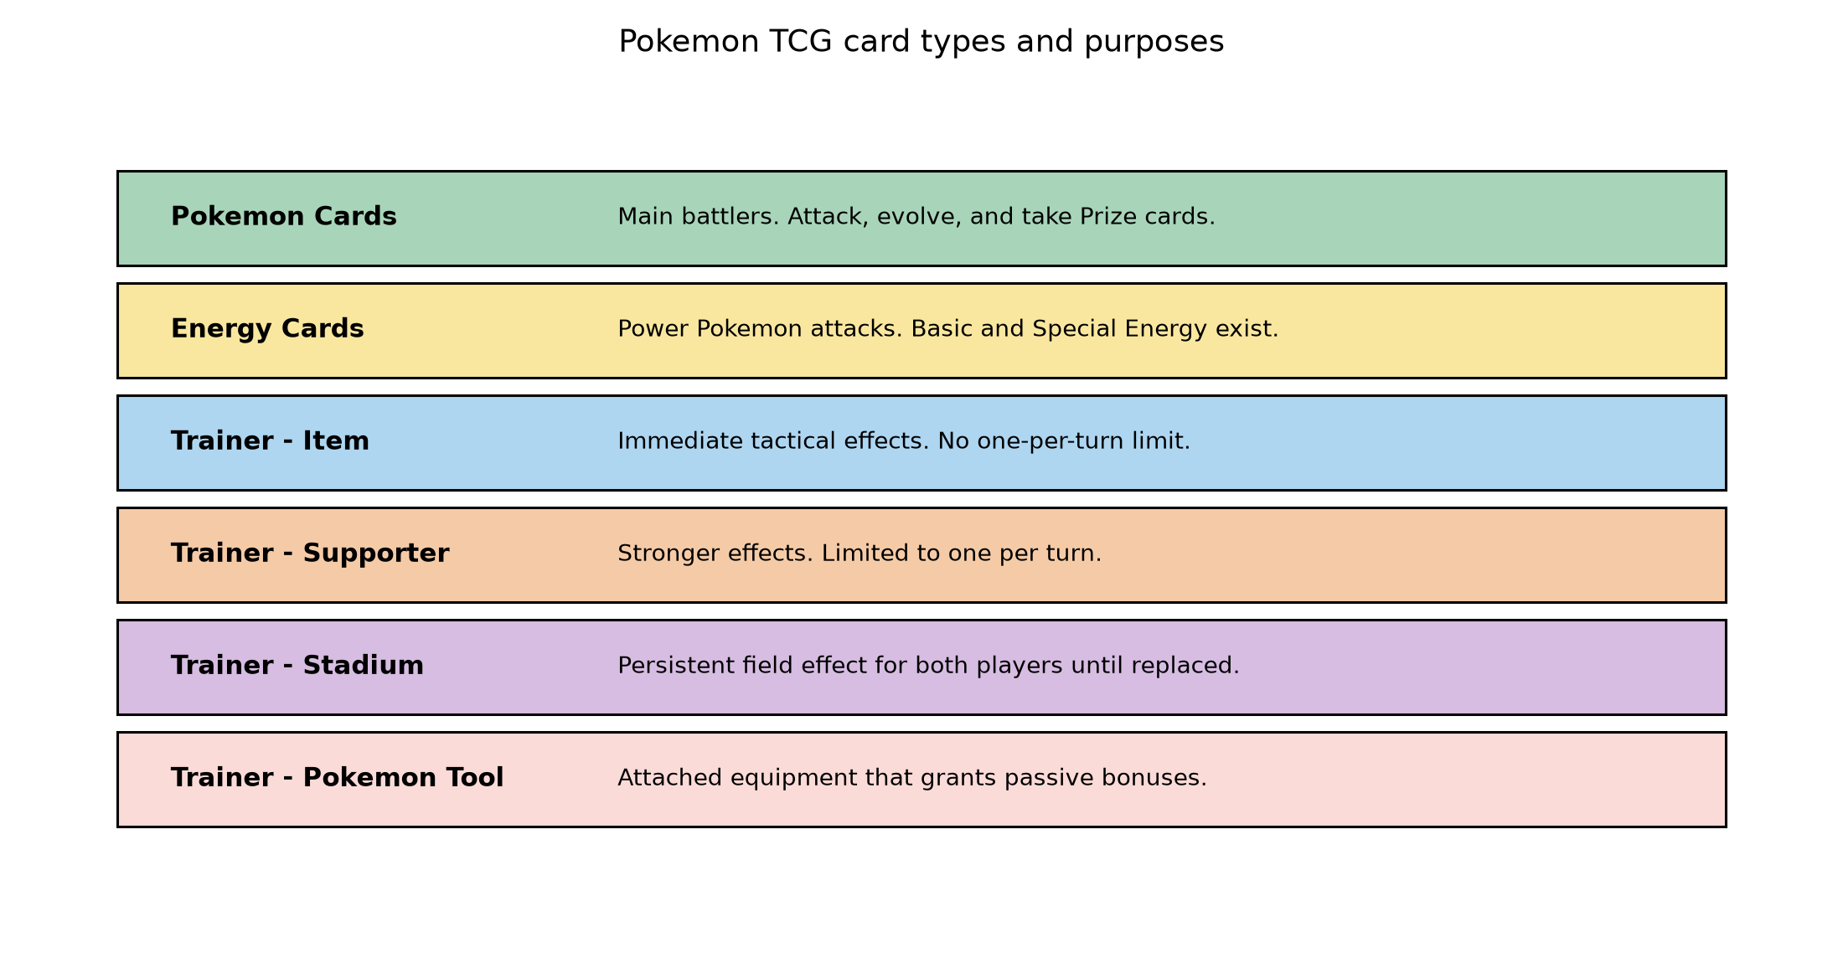

1. Investigation

1.1 Project schedule
- Day 1: brief and scope lock.
- Day 2: problem outline and detailed description.
- Day 3: ethical, legal, security, data integrity analysis.
- Day 4: ERD, relational notation, data dictionary, SQL query list, structure chart and function specifications.

1.2 Problem outline
Purpose: internal admin interface for authorised staff to manage platform records without writing SQL.
Users: platform administrators, support staff, tournament organisers.
Objectives: accurate records, efficient CRUD workflows, strong validation and reporting support.

1.3 Detailed problem description
Staff use a Python menu interface backed by SQLite to create, search, update and delete players, card data, decks and tournaments. The system enforces data quality using constraints and validation while supporting report generation for operational decisions.

1.4 Functional requirements
- Manage player accounts (add/search/update/delete).
- Manage card and card set records.
- Create and maintain decks and deck-card quantities.
- Create tournaments and maintain tournament registrations.
- Generate administrative statistics and reporting output.
- Keep change-friendly and traceable records.

1.5 Non-functional requirements
- Usability: clear menu prompts and consistent navigation.
- Performance: quick filtered searches on class-scale data volumes.
- Reliability: transaction-safe updates to related data.
- Security: parameterised SQL and access restriction assumptions.
- Maintainability: modular function design and shared DB helpers.
- Integrity: PK/FK/NOT NULL/UNIQUE/CHECK constraints.

1.6 Ethical legal security considerations
- Protect player data using minimal collection and controlled access.
- Respect card-data intellectual property by using public reference metadata for educational scope.
- Use parameterised SQL to reduce injection risk.
- Maintain periodic backups during development and testing.

1.7 Data quality and integrity
- Duplicate prevention with UNIQUE constraints (e.g., email, set code).
- Completeness with NOT NULL on required fields.
- Validity with CHECK constraints (rarity, positive quantity).
- Referential integrity with foreign keys to stop orphan records.
- Consistency with transactions for multi-step writes.

2. Database design

2.1 ERD
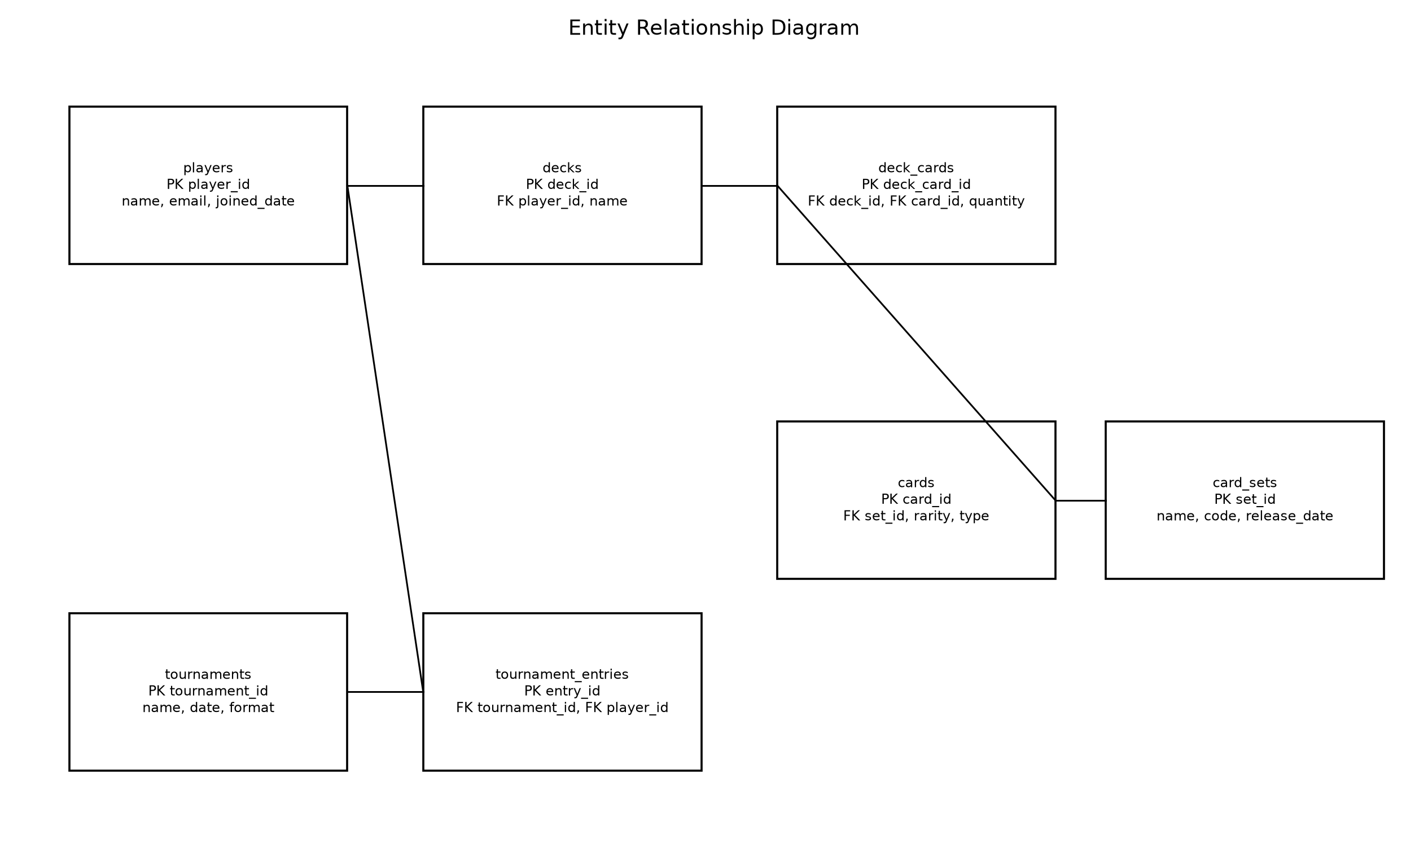

2.2 Relational notation
- players(player_id PK, name, email UNIQUE, joined_date)
- card_sets(set_id PK, name, code UNIQUE, release_date)
- cards(card_id PK, set_id FK, name, rarity, card_type, mana_cost)
- decks(deck_id PK, player_id FK, name, created_date)
- deck_cards(deck_card_id PK, deck_id FK, card_id FK, quantity CHECK > 0)
- tournaments(tournament_id PK, name, start_date, format)
- tournament_entries(entry_id PK, tournament_id FK, player_id FK, registration_date)

2.3 Data dictionary
Table: players
Field | Type | Constraints and purpose
player_id | INTEGER | PK AUTOINCREMENT
name | TEXT | NOT NULL
email | TEXT | UNIQUE
joined_date | TEXT | ISO date

Table: card_sets
Field | Type | Constraints and purpose
set_id | INTEGER | PK AUTOINCREMENT
name | TEXT | NOT NULL
code | TEXT | UNIQUE
release_date | TEXT | ISO date

Table: cards
Field | Type | Constraints and purpose
card_id | INTEGER | PK AUTOINCREMENT
set_id | INTEGER | FK card_sets(set_id)
name | TEXT | NOT NULL
rarity | TEXT | CHECK values
card_type | TEXT | nullable
mana_cost | TEXT | nullable

Table: decks
Field | Type | Constraints and purpose
deck_id | INTEGER | PK AUTOINCREMENT
player_id | INTEGER | FK players(player_id)
name | TEXT | NOT NULL
created_date | TEXT | ISO date

Table: deck_cards
Field | Type | Constraints and purpose
deck_card_id | INTEGER | PK AUTOINCREMENT
deck_id | INTEGER | FK decks(deck_id)
card_id | INTEGER | FK cards(card_id)
quantity | INTEGER | CHECK > 0

Table: tournaments
Field | Type | Constraints and purpose
tournament_id | INTEGER | PK AUTOINCREMENT
name | TEXT | NOT NULL
start_date | TEXT | ISO date
format | TEXT | nullable

Table: tournament_entries
Field | Type | Constraints and purpose
entry_id | INTEGER | PK AUTOINCREMENT
tournament_id | INTEGER | FK tournaments(tournament_id)
player_id | INTEGER | FK players(player_id)
registration_date | TEXT | ISO date

2.4 SQL query list in plain English
- Display all tournaments a selected player has entered.
- Search cards by rarity.
- List cards and quantities for a selected deck.
- Display players with the largest card collections.
- Calculate players registered in each tournament.
- Insert new player records.
- Update selected records.
- Delete selected records.

3. Software design

3.1 Structure chart
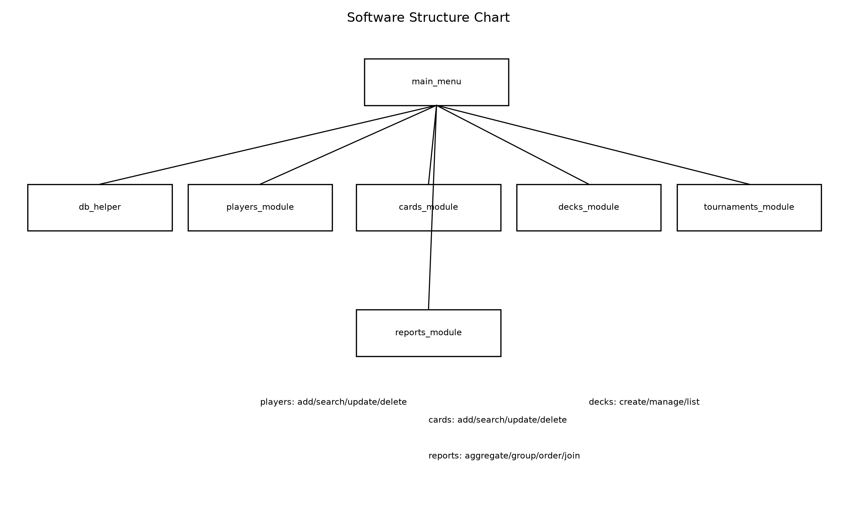

3.2 Function specifications
Function | Purpose | Parameters | Return
connect_db(path) | open sqlite connection and enable foreign keys | path | connection
create_player(conn, name, email) | insert validated player record | conn name email | player_id
search_player(conn, term) | find player rows by name or email | conn term | row list
update_player(conn, player_id, ... ) | update existing player details | conn player_id fields | success flag
delete_player(conn, player_id) | delete player and dependent data per FK rules | conn player_id | success flag
create_card(conn, ... ) | insert card linked to set | conn fields | card_id
create_deck(conn, player_id, name) | create deck for player | conn player_id name | deck_id
add_card_to_deck(conn, deck_id, card_id, quantity) | insert/update deck card quantity | conn ids quantity | none
create_tournament(conn, ... ) | insert tournament | conn fields | tournament_id
register_player_tournament(conn, tournament_id, player_id) | insert tournament entry | conn ids | entry_id
generate_report_tournament_entries(conn) | join/group/order report rows | conn | row list

3.3 Interaction between Python and SQLite
- Main menu receives user selections and passes data to module functions.
- Module functions validate user input before SQL operations.
- Database helper executes parameterised SQL and controls commits/rollbacks.
- Report functions run joins, aggregates, grouping and ordering for output.

